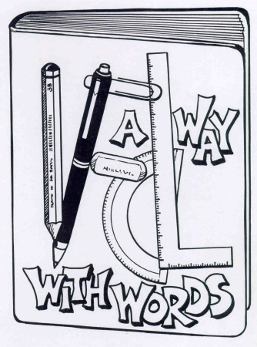
A Way With Words:
three day creative writing workshop
Application Form
Do you enjoy writing? Do you write in your spare time? Nothing to do in the school holidays? If so, you could join 20 likeminded young people in this exciting workshop to be held in the Library at Bethany Lutheran Primary School, 126 Cascade St., Raceview.
Over three jam-packed days, Monday 29th June – Wednesday 1st July, you will be immersed in the joy of writing with popular author Brian Falkner of Story Sports fame.
Interested? Please complete the application form below to be considered for the program.
Applications close Friday 19th June 2015.
All successful and unsuccessful applicants will be contacted via email by Wednesday 24th June.

Application Requirements
We are looking for 20 committed and passionate young writers from the Ipswich region or IDTL Network schools.
Please complete all details on the application form.
The panel will use the criteria and take content gathered from within the application into account when assessing applications.
Please keep a copy of the application for your records.
The complete application must be emailed to info@idtl.net.au
or posted to IDTL Network, Bethany Lutheran Primary School, 126 Cascade St, Raceview 4305
before 3pm, Friday 19th June 2015.
Enquiries or requests for further information should be directed to info@idtl.net.au .

A Way With Words Application Form (Type in the spaces so you can email the application or write neatly)

Contact details
- Name in full:

- Gender (M/F):

- Current age:

- Contact details
Parent/guardian name:
Email:
Phone:
- School:
Please type/write neatly your responses to the question below and note the word limit:
- Why A Way With Words?
In 100 words or less, tell us why you want to attend the A Way With Words program.

- Your Words.
In 100 words or less write a short story that includes the word journey.

Terms and conditions:
If successful, one place in the A Way With Words program will be offered. The cost for each place is $75. The Ipswich District Teacher-Librarian Network is subsidising the remainder of the workshop costs, and the workshop is valued at approximately $300 per participant. An invoice will be emailed to successful applicants.
To be eligible, applicants must be:
- Available for the full period of the workshops from Monday 29 June – Wednesday 1 July from 9am – 3pm
- Aged 10 – 14 years
Declaration:
(By typing my name) / I agree to the terms and conditions of the program and that this application is in my own words.
E-/Signature: Date:
(By typing my name) / I agree to the terms and conditions of the program and allow my child to participate.
E-/Parent/guardian signature: Date:

